

Dr. Muhammad Aslam

maslam@uet.edu.pk

Submitted By

Hamza Farooq

2020mscs513@student.uet.edu.pk

Komal Shehzadi

2020MSCS590@student.uet.edu.pk

Submitted to

4/24/2021

DRONE-BASED TRAFFIC MONITORING SYSTEM

A multi-agent system responsible for traffic surveillance

Table of Contents

Abstract 2

Introduction 3

Environment 3

Perception 3

Problem Definition 4

Operational Objectives 5

Native Monitoring Techniques 6

Real Time Systems 6

Data Analysis Systems 6

Drone Based Monitoring Techniques 7

System Components 7

Aircraft Unit 7

Camera and Gimbal Control 8

HD Transmitter and Receiver: 8

Ground Station 8

Native Monitoring vs Drone Based Monitoring System 9

Discrete Infrastructures and USE CASES 10

Multi Rotor Drones 10

Traffic and Suspicious Activity Detection 11

Definition: 11

Vehicle Detection from Ariel Imagery 11

Vehicle Tracking using Mean Shift Tracking Algorithm 12

Moving Target Indication 13

Overview of all the strategies 14

Deductive Reasoning 15

Conclusion 16

References 16

# Abstract

Unmanned Aerial Vehicles (UAVs) or “Drones” have gained attention among the public and private sectors. Practical applications such as facility inspection, mapping, surveillance, delivery, etc. have been intensively tested. Over the last decade, UAV applications in transportation engineering have included experiments with traffic surveillance, infrastructure monitoring, and roadway incident management. Most have focused on transmitting on-site video footage to traffic management centers so traffic operators can monitor congestion, coordinate incident response crews, or collect traffic data in areas without CCTV surveillance systems. In this document, the focus is to explore the feasibility of using UAV to accelerate the site surveying at major traffic monitoring and management system with comprehensive tracking and detection algorithms. With each technique, the respective use case is also discussed. A prototype UAV system that can be rapidly deployed in the field for video-based site surveying and 3D reconstruction of accident sites has also been proposed.

# Introduction

The traffic jam is a daily-life problem in any metropolitan city. With the rise of standard of living, the number of vehicles is increasing at an exponential rate. In response to this, many research and practical implementation are done in developing a traffic monitoring system (TMS), i.e., a traffic monitoring system which is involved in a much closer interaction with all the components of a traffic including vehicles, drivers, and even pedestrian. It not only provides safety at intersections and prevents traffic jam but manages the traffic.

The augmentation of drones is a beneficial and efficient approach in this monitoring system. Drones have an imprudent usage in Military, Surveillance, Medicine and Photography. But an idea of interconnecting these smart agents to develop a complete network for prefection is all that is discussed in this indenture. Furthermore, there are different surveilling techniques and hardware indentation that will be elucidated later.

# Structure of Agent

The internal hardware and software structure of the agent is responsible for making a drone an agent or particularly intelligent agent. The key characteristics of agent structure are

* An infrared active camera is installed on the drone, which is capable of capturing videos at very high frame rate and in high to low light exposure.
* The data from drone is continuously being transferred to central ROS (Robot Central System) which has OpenCV and other image interpretation programs installed on it.
* After the estimation of frame of reference, the data is further processed in a server on the Unity game engine platform.
* An optional operator is also available to provide manual control in some special case where the intelligent decision making of the agent is being tested.

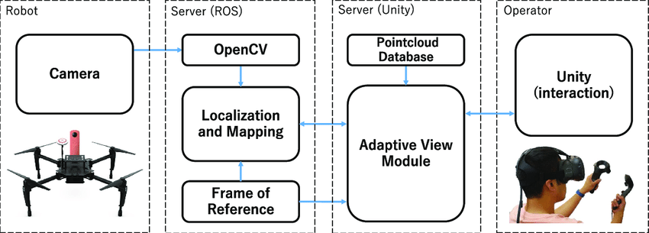

# Environment

Drone based surveillance agents encounter real time environment so it has these following environment properties:

|  |  |
| --- | --- |
| **Environment** | **Reason** |
| Inaccessible | Since the action in a traffic, surveillance environment does not guarantee the outcome. |
| Non-deterministic | Environment is real time so it is hard to determine its state. |
| Episodic | Agent encounters infinitely many environment states, which are changeable, linkage between two states. |
| Dynamic | Traffic environments are continuously changing so they are dynamic in nature. |
| Continuous | Traffic environment keeps on changing because its real time so it depicts a continuous environment |

# Perception

Drone based surveillance agent percept its action by a series of sensors. These can be hardware sensors in real time/ human environment and software sensors in software environment.

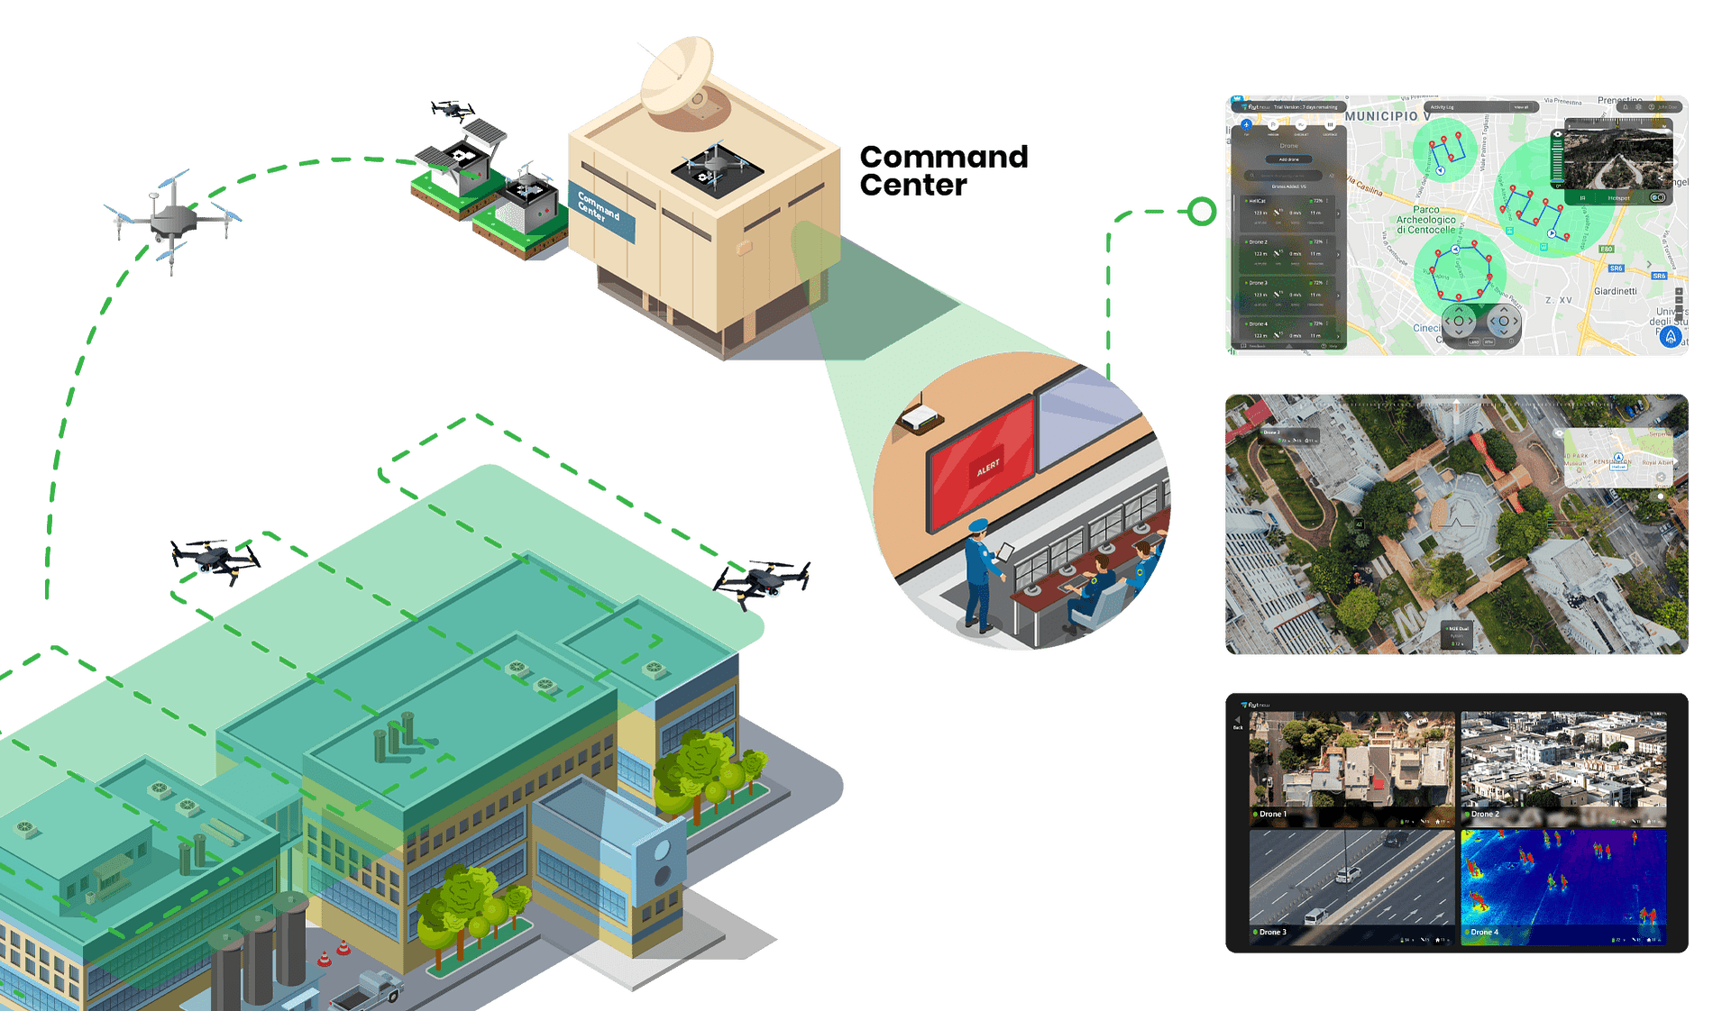

* The *see* function is the agent’s ability to observe its environment, whereas the *action* function represents the agent’s decision-making process
* *Output* of the *see* function is a *percept*:

*see*: *E* → *Per*

which maps environment states to percepts, and *action* is now a function

*action*: *Per\** → *A*

which maps sequences of percepts to actions

|  |  |
| --- | --- |
| **Percepts** | **Actions** |
| See (Fake plate) | Alert police, follow the vehicle and coordinate with another agent to tackle the situation. |
| See (high speeding vehicle) | Note its number and add its challan information in database |
| See (normal environment) | Do nothing |

# Problem Definition

The primary idea for the system is a matrix of drones mushed together, tracking vehicles. If a vehicle is detected to be violating or more specifically identified as suspicious then the left behind drone sends signal to the upcoming drone and the nearest station so that the vehicle is tracked down in time and stopped if necessary. It is more like an e-challan technique. But in this, there will be drones spooring rather than CCTV.

The above flow chart indicates a basic idea for one unit of the matrix. There must be a series of parallel units receiving the upcoming signals and trackers which then at a point makes a complete web resulting our system.

# Operational Objectives

Drones can provide on-ground situational awareness in case of emergencies like road accidents, oil leaks etc. and collect evidence for the same. The data collected by drones can be analyzed to improve traffic flow and road safety.

Detecting a vehicle violating the rule is sometimes tougher and somewhat costly when it comes to street camera or CCTV. It is difficult to install CCTV all over the city and maintain them with a server room where all the recordings are kept. Apart from the storage issue, if we look just at the hardware installation, it is both difficult and riskier.

For Example, let us take a Use case. A fast-driving car violating the speed limit crosses the road in rage. The CCTV captures the car data, the number plate car color, model and some more details like this, it can then be monitored by the backend which is deployed in the server room. The police can then take some action and track the car down. All of this can be done very quickly but there is one major drawback in this, i.e., it is laborious as compared to the level of result because of the CCTV being static and having a limited range. The result is not desired when it comes to the close movements and details.

On the other hand, when it comes to drones or UAV Unnamed Aerial Vehicle, following pros comes hand in hand.

1. Intelligence
2. Networking
3. Efficiency

The smart agents or UAV will watch and detect any kind of abnormality and inform the connected agent. This kind of intelligent behavior with very less consumption of energy and a high source backend networking makes the monitoring system a treat.

# Native Monitoring Techniques

ITS is being researched and implemented through various means such as the use of wireless sensor networks, RFID, applying various concepts of graph theory to find the minimized path and many other. Here, the concept of ITS has been classified into two broad domains, namely, (I) real-time system and (II) data analysis system. Real-time systems have been further diversified into two fields: I. Path optimization and II. Traffic density. The data analysis systems are also divided into two parts: i. Green light optimization, ii. Information chaining systems

## Real Time Systems

Real-time systems in case of traffic managing system take the input of the current situation through video surveillance or WSNs and deal with the situation(Biswas et al., 2015). The traffic signals are controlled according to the presence of vehicles and are operated automatically in real time. A real-time optimization model was used that investigated the issue of traffic control in urban areas. The model took into considerations the traffic scenarios which also include pedestrians. This technique was applied for analyzing real case studies. The main purpose is to concentrate on calculating the time that a vehicle requires to reach the intersection from a particular point, dynamically, using sensors. By this, data performs various calculations to find the green light length. Albers et al. used real-time data to monitor current traffic flows in a junction so that the traffic could be controlled in a convenient way. Reliable short-term forecasting video captured in a recorder plays an important role in monitoring the traffic management system. The data required can be easily provided by the CCTV cameras that can be beside the roads as per requirement. Transportation incident management explorer (TIME) is also used for calculating real-time data. A distributed wireless network of vehicular sensors to get a view of the actual scenario and used its various sectors to lower the congestion but not taking decisions in real time is one of the purposed detains. The use of two types of sensor network was proposed, vehicular sensor network and wireless sensor network, and the combination of these two permits the monitoring as well as managing of the traffic. Video surveillance is also used for realizing the real-time scenario.

## Data Analysis Systems

Data analytical systems are those systems that take the present or statistical data, process them in the processor, and then act according to predefined algorithm. Like real-time systems, it may collect data in real time, but is unable to take any decision in real time, i.e., it must follow the instructions that are provided to it. Yousef et al. suggested a scheme of solving traffic congestion in terms of the average waiting time and length of the queue at the isolated intersection and provide efficient flow in global traffic control on multiple intersections with the accordance of real-time data. Thus, the data collected can be used in various ways depending on the perspective of the user.

# Drone Based Monitoring Techniques

The UAV Unnamed Aerial Vehicle based network for investigation, management, and coordination during traffic incidents. The system is constituted predominantly for incident management to develop an economically justifiable case for the use of UAVs in traffic management. The previous studies aiming at replacing the existing traffic surveillance system with UAVs are difficult to justify financially and technologically given the apparently fast development and sophistication in ground-based vehicle detection systems. One example fast-growing system includes the mobile sensor technologies such as GPS, Bluetooth, and cellphone-based traffic detection. Traffic incidents are events such as traffic accidents, road spills, and vehicle breakdowns that occur at random locations and times. Such stochastic nature in space and time makes the existing fixed-location traffic surveillance systems insufficient sometimes in covering and observing traffic incidents(Manager et al., 2016). Furthermore, the strong need of information distribution especially related to traffic diversion and secondary incident prevention makes a temporary mobile multi-functional management system like Air-TIMS a suitable alternative. To justify the cost-effectiveness, evaluation indexes such as incident clearance time and traffic recovery time can be easily defined and evaluated.

## System Components

The system entails hardware as well as software components. All of the on-demand entities for the project are discussed below.

## Aircraft Unit

The UAV proposed for this system has mainly composed of three components declared as following.

1. UAV Unnamed Aerial Vehicle
2. Built-in GPS and transceiver
3. Batteries and camera Gimbal

Figure 2. UAV Unit Components, an overview (a) UAV (b)GPS and transceiver (c) Flying UAV (d)Camera Gimbal

Camera and Gimbal Control: The camera gimbal was built in a way to stabilize the camera in both roll and pitch axis using the electronic stabilizers for better video and image recording. The camera gimbal can be either controlled manually via wireless communication for changing the pitch and roll angle (camera angle) or automatically with the UAV using the flight plan. The yaw dimension unit was removed to save the payload and increase the stability of the platform. The camera used in this study is SONY HXR-NX30U(8) which has the capability of HD video recording, image shooting, wireless control communication, built-in GPS, and lens stabilizer. The wire communication control includes zooming and recording and image shooting. Both camera and gimbal can be controlled using 2.4 GHZ controller.

HD Transmitter and Receiver: HD transmitter and receiver was used in this study is Paralinx Tomahawk(9). It can transmit HD video via 5.8 GHZ communication link up to 800 meters.

Ground Station: Ground station units includes the following:

1. Laptop
2. USB transceiver
3. HD receiver and external Monitor
4. Video image capture card
5. UAV and camera Controllers

Mission planner will be installed on the laptop for flight status monitoring, flight planning development and uploading the flight plan on the UAV using the transceiver on the UAV and laptop.

# Native Monitoring vs Drone Based Monitoring System

There are different aspects in which both systems have their own approach to tackle with the situation. Both Systems have been Compared below.

|  |  |  |  |
| --- | --- | --- | --- |
| **Native Traffic Monitoring System** | | **Drone Based Monitoring System** | |
| **Technique Name** | **Efficiency** | **Technique Name** | **Efficiency** |
| **Traffic Density:**  Finding the density of vehicles along a road and follow a certain algorithm to direct the vehicles | On spot detection and handling of traffic. Requires good financial investment | **Communication Relay Nodes:**  UAVs can act as relay nodes, which connect disconnected mobile ad hoc network (MANET) clusters. In this case, nodes belonging to different disconnected clusters can communication with each other by using a UAV, which can be placed in a strategic position between the two clusters. | provide robust and reliable connectivity for all of the clusters in the MANET. |
| **Path Optimization:**  Deciding an optimal path, for an incoming vehicle based on the traffic present at the approaching junction | Real-time analysis of data to find an easy path, but not applicable for all situations where alternative path is not present | **Network Gateways:**  In remote geographic or disaster-stricken areas, one or more UAVs can provide connectivity to backbone networks, communication infrastructure, or the Internet by acting as gateway nodes. | Rapidly and efficiently deployed to perform this task in a very dynamic, and cost-effective manner |
| **Information Chaining System:**  To inform the vehicles about the traffic along any lane and directing them to change to another route if necessary | Useful in routing of vehicles in an optimized path, but highly developed and error-free system is required else ambiguous situation may arise | **Assisted Sensing:**  A range of UAV applications require multiple collaborative UAVs to sense an area or to inspect an infrastructure using one or more types of sensors like cameras, heat sensors, radiation readers and different gas monitors. | UAVs together in organizing the operations and collectively gathering accurate and reliable information results in accurate and reliable solution. |
| **Green Light Optimization:**  Use of different logics like fuzzy logic and other simulation techniques to determine the green light length so that every lane is provided with some appropriate time slot | Highly efficient system. Requires large capital for implementation | Distributed Versus Centralized Control:  the middleware, which resides between the application and transport layer of each node., the gateway node has additional functions such as data aggregation, UAV to-Infrastructure QoS mapping, and other interface services. | Bottleneck for communication and security and provides safe operations and maintain the fault tolerance mechanism. |

# Discrete Infrastructures and USE CASES

Following are the different types of UAV based monitoring techniques and algorithms and their respective parameters that makes them suitable for the use case of each type.

## Multi Rotor Drones

Multi Rotor drones are the most common types of drones which are used by professionals and hobbyists alike. They are used for most common applications like aerial photography, aerial video surveillance etc. Different types of products are available in this segment in the market – say multi-rotor drones for professional uses like aerial photography (whose price may range from 500USD to 3K USD) and there are lots of variants for hobby purposes like amateur drone racing, or leisure flying (price range from 50USD to 400USD). Out of all the 4 drone types (based on aerial platform), multi-rotor drones are the easiest to manufacture and they are the cheapest option available as well.

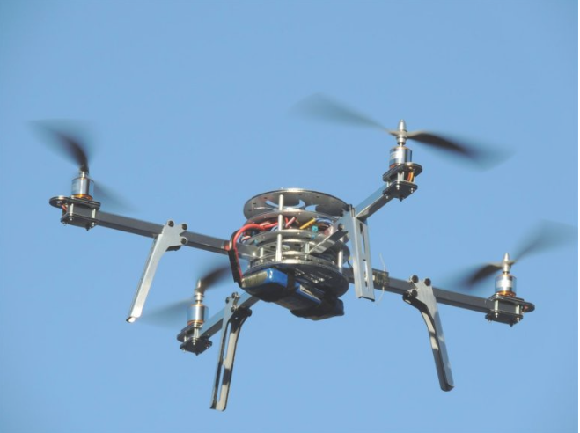

## Traffic and Suspicious Activity Detection

### Definition:

*The on-Duty UAV units detect any suspicious activity in traffic*.

Suppose there is traffic on the road. There can be many kind of suspicious activity at that point. A car having no number plate, breaks rules. The driver is texting while driving or exceeds the speed limit, or has no number plate, it is detected by the on-Duty agent, while keeping in view the other moving vehicle.

Figure:

While warrants are appealing to privacy advocates, the enactment of overly broad restrictions on drone use can curtail non-invasive, beneficial uses of drones. The drones are fitted with infrared video cameras to catch reckless drivers and improve road safety. They take video footage of accidents and identify locations with major traffic jams to help patrol cars clear these areas and carry out their duties more effectively.

### Vehicle Detection from Ariel Imagery

The Vehicle is detected By using different edge detection and corner detection algorithms, Most popular are Histogram Oriented Gradients and Harris Corner Detector. This is done by a feature descriptor converts an image of size width x height x 3 (channels) to a feature vector / array of length n. In the case of the HOG feature descriptor, the input image is of size 64 x 128 x 3 and the output feature vector is of length 3780.

 The feature vector is not useful for the purpose of viewing the image. But, it is very useful for tasks like image recognition and object detection(Kanistras et al., 2007). The feature vector produced by these algorithms when fed into an image classification algorithm like Support Vector Machine (SVM) produce good results.

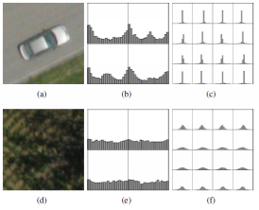

Figure 2: Vehicle in aerial image (a), corresponding HoG features (b) and Gabor histograms (c). Vegetation region in aerial image (d), corresponding HoG features (e) and Gabor histograms

### Vehicle Tracking using Mean Shift Tracking Algorithm

The building of object models according to known target appearance and possible areas that those may appear it is proposed that during the matching process, which is important for tracking purposes, it is suggested that the object’s bounding box should be fixed so the probabilistic density function value can be calculated afterwards(Godinho et al., 2015). Although, when the algorithm is applied to UAVs, since the objects are small and moving rapidly, the algorithm may converge into a region of background. To reduce the mistakes in the Mean Shift algorithm, particle filtering is suggested. According to the author the Mean Shift algorithm along with particle filtering can solve the problems caused by fast moving objects in UAV videos.

**Figure: mean shift algorithm, a basic tracking visual**

**Figure : Flow chart of mean shift algorithm output the segmented data**

Mean shift is a simple iterative procedure that shifts each data point to the average of data points in its neighborhood. This generalization makes some k-means like clustering algorithms its special cases. It is shown that mean shift is a mode-seeking process on a surface constructed with a “shadow” kernel. For Gaussian kernels, mean shift is a gradient mapping. Convergence is studied for mean shift iterations. Cluster analysis is treated as a deterministic problem of finding a fixed point of mean shift that characterizes the data. Applications in clustering and Hough transform are demonstrated. Mean shift is also considered as an evolutionary strategy that performs multistate global optimization.

## Moving Target Indication

MTI (Wang et al., 2011)Moving Target indication primarily revolves around detecting moving objects on the ground with video cameras that are mounted on unmanned air vehicles. The main approach is to compare pairs of image frames that are captured a short time apart. This approach is not based on image registration but on the analysis of the motion of the features with respect to a static scene model. The feature analysis is divided in three stages. First, a pair of image frames is used to locate the fixed objects. A method based on random consensus RANSAC is used to calculate a matrix with the largest number of matched features. Then, during the second stage the objective is to obtain an improved stationary and moving classification. A temporal analysis is done on results from many frame pairs to identify the set of features that are judged to be moving or stationary with high confidence. In the last stage, a process for further improvement of the performance is used for the remaining false alarms that are caused by the missing targets. The algorithm is evaluated on frames of a motorway roundabout and a car park of a supermarket.

Figure: A result of improved stationary and moving classifications

## Overview of all the strategies

An Overview of all the strategies that are explained above is given below

|  |  |  |  |
| --- | --- | --- | --- |
| **Aerial Imagery** | **High-Definition Imagery** | **Mean Shift Tracking** | **Moving Target Indication** |
| **Efficiency:**  A reasonably accurate estimate of the overall accuracy of the program is achieved by using the threshold of the fast detection algorithm | **Efficiency:**  High-definition air-born imagery is used efficiently for obtaining traffic flow data. | **Efficiency:**  Mean Shift algorithm along with particle filtering can solve the problems caused by fast moving objects in UAV videos. | **Efficiency:**  Performs well on the datasets from the supermarket even with complex 3D structures. |
| **Constraints:**  Due to its ability to retain nearly all the vehicles in the set while successfully reducing the false positives by half. | **Constraints:**  Vehicles are tracked and traffic parameters are calculated. Keeping in view the adequate Sampling. | **Constraints:**  Small objects are rarely lost which makes this algorithm valuable in UAV videos to track fast small moving objects like vehicles in highways. | **Constraints:**  False alarms and missing targets remain even after the stage two thus some clearly moving objects are not detected. |
| **Analysis:**  The rotation invariant HoG, did not perform well due to the reflective water that was in the background. | **Analysis:**  Only a small group of vehicles was able to be tracked for a long distance due to 6 sec Video limitation. | **Analysis:**  The Mean Shift can track the objects on time only when the objects are known. | **Analysis:**  The geometrical interpretation of the scene is not well constrained and that causes problems even with a smooth traffic flow on the motorway. |

# Control Loop

Agent control loop (general):

while true

observe the traffic in range:

validate every vehicle following rules:

use perceptions to get the action for ensuring traffic rules;

execute the action

validate all the normal conditions:

do nothing;

end while

Agent control loop use case (fake license plate)

while true

observe the traffic in range:

validate if a vehicle has fake number plate:

use a list of actions to create a plan like, note its information and expected location and inform control center;

execute the plan

validate all the vehicles has original plates:

do nothing;

end while

Agent control loop use case (High speeding vehicle)

while true

observe the traffic in range:

validate if a vehicle is crossing speed limit:

use a list of actions to create a plan like, note its information and create a challan to send at residential address;

execute the plan

validate all the vehicles are moving in normal speed limit:

do nothing;

end while

These control loops can be created for all the rules in deduction based on percepts and actions.

# Deductive Reasoning

(x, y, z) starts from (0,0,0) which is starting point for agent on map. Since drone moves in 3d space so we have to keep track of all 3 dimensions. A night vision camera will be used by agent for surveillance at night. Each agent will cover 1000 meters in all directions. Whenever an agent moves forward it will signal other agents since it’s a multiagent system environment all agents will coordinate with each other to rescue the situation. These drone agents will be connected to a shared network from where they will fetch data to observe the situation and in which the violation data will be stored so the agents will be in sync. Each action which depicts will be saved and each agent’s camera will be programmed to detect it.

Deduction rules

1. In (x, y, z) ∧ See (person driving with a suspended license) −→ Do (save the record in database) Do (alert police)
2. In (x, y, z) ∧ See (Fake Plate vehicle) −→ Do (Inform Police) ∧ Do (Save car plate number) ∧ Do (follow it)
3. In (x, y, z) ∧ See (Speed limit crossing vehicle) −→ Do (Save a challan in database by the car information) ∧ Do (send challan at owner’s address)
4. In (x, y, z) ∧ See (Swerving) −→ Do (Save a challan in database by the car information) ∧ Do (send challan at owner’s address)
5. In (x, y, z) ∧ See (not wearing a seat belt) −→ Do (Save a challan in database by the car information) ∧ Do (send challan at owner’s address)
6. In (x, y, z) ∧ See (not securing young passengers in a child safety seat) −→ Do (Save a challan in database by the car information) ∧ Do (send challan at owner’s address)
7. In (x, y, z) ∧ See (Talking on a cell phone) −→ Do (Save a challan in database by the car information) ∧ Do (send challan at owner’s address) ∧ Do (alert police)
8. In (x, y, z) ∧ See (Failure to observe slow sign) −→ Do (Save a challan in database by the car information) ∧ Do (send challan at owner’s address)
9. In (x, y, z) ∧ See (Failure to observer stop sign) −→ Do (Save a challan in database by the car information) ∧ Do (send challan at owner’s address)
10. In (x, y, z) ∧ See (Moving a wrong lane) −→ Do (Save a challan in database by the car information) ∧ Do (send challan at owner’s address)
11. In (x, y, z) ∧ See (Failure to observe traffic signals) −→ Do (Save a challan in database by the car information) ∧ Do (send challan at owner’s address)
12. In (x, y, z) ∧ See (Driving with rear screen partially or fully covered) −→ Do (Alert police with a suspicion threat)
13. In (x, y, z) ∧ See (Driving with improper lights at night) −→ Do (Alert police to tackle the situation)
14. In (x, y, z) ∧ See (Jumping traffic queue) −→ Do (Alert police to tackle the situation)
15. In (x, y, z) ∧ See (Moving a wrong lane) −→ Do (Save a challan in database by the car information) ∧ Do (send challan at owner’s address) ∧ Do (Alert police)
16. In (x, y, z) ∧ See (One Wheeling) −→ Do (Save a challan in database by the car information) ∧ Do (send challan at owner’s address) ∧ Do (Alert police)
17. In (x, y, z) ∧ See (Normal Environment) −→ Do (forward) ∧ Do (coordinate with other agents about their position)
18. ….

These rules repeat at every new location (x, y, z) based on the see function of drone agent.

# Conclusion

UAVs can be very useful for traffic monitoring. However, issues with UAV deployment for civil applications must be addressed. Maneuverability and wireless network communication are two of the key points that make unmanned air vehicles more useful than the other methods currently used. The capability of tracking vehicles on the ground and allowance of the transmission and reception of instructions and image and video information to a ground base could be used on board (Radar, Vision, Hybrid), but also on the type of processing (on-board, off-board) of the data in vision sensors.

# References

Biswas, S. P., Roy, P., & Patra, N. (2015). *Intelligent Traf fi c Monitoring System*. *October*, 535–545. https://doi.org/10.1007/978-81-322-2523-2

Godinho, G. G., França, F. D. O., Freitas, J. M. A., Santos, F. M. L., Prandini, A., Godinho, A. C., & Costa, R. P. D. P. (2015). Resultado do tratamento cirúrgico artroscópico das rerrupturas do manguito rotador do ombro. *Revista Brasileira de Ortopedia*, *50*(1), 89–93. https://doi.org/10.1016/j.rbo.2014.03.007

Kanistras, K., Martins, G., & Rutherford, M. J. (2007). *A Survey of Unmanned Aerial Vehicles ( UAVs ) for Traffic Monitoring*.

Manager, E. P., Motiani, D., & Commissioner, A. (2016). Unmanned Aerial Vehicle (UAV) Based Traffic Monitoring and Management. *DOT National Transportation Integrated Search - ROSA P*, *August*. https://rosap.ntl.bts.gov/view/dot/36710

Wang, J., Liu, J., Meng, J., & Han, M. (2011). Research on an improved mean shift algorithm. *Procedia Engineering*, *15*, 3572–3576. https://doi.org/10.1016/j.proeng.2011.08.669